Q1.
Answer is C.

A: UNION combines all unique employee_ids from both tables.
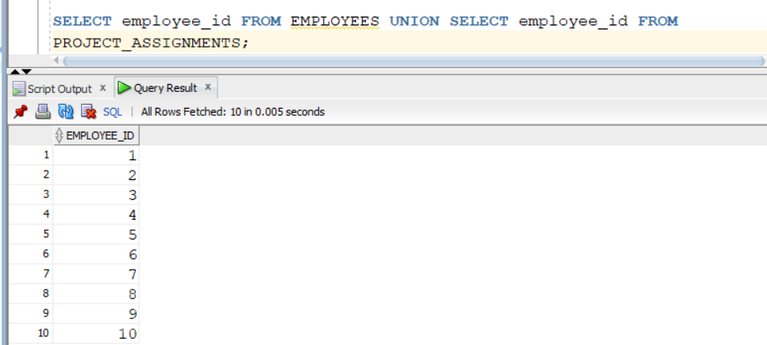

B: INTERSECT returns only the employee_ids that exist in both tables.
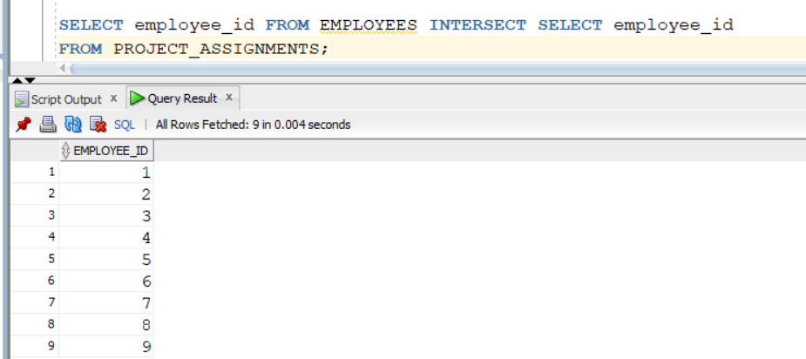

C: MINUS returns rows in the first query (EMPLOYEES) that do not exist in the second query.
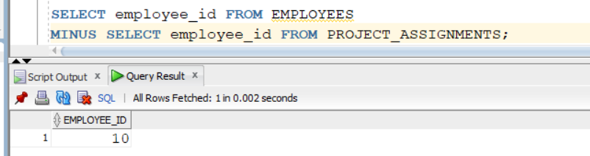

D:UNION ALL combines all rows from both tables, including duplicates.
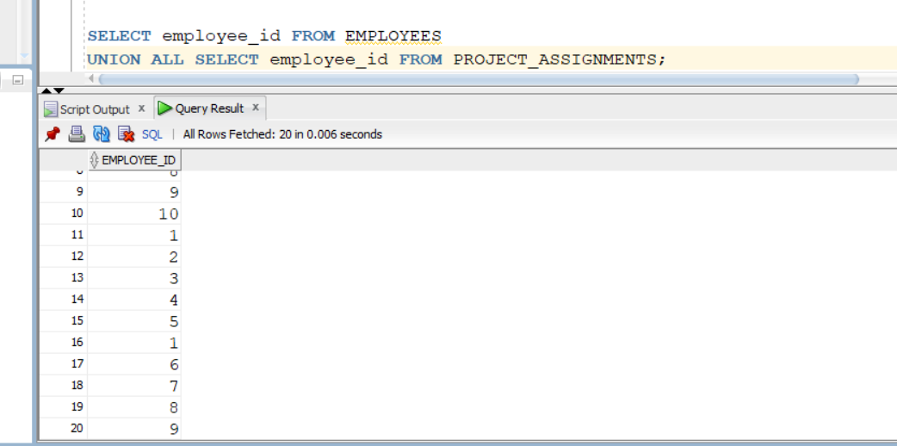

Q2.
Answer is B.

A: UNION combines all distinct customer IDs from the three tables.
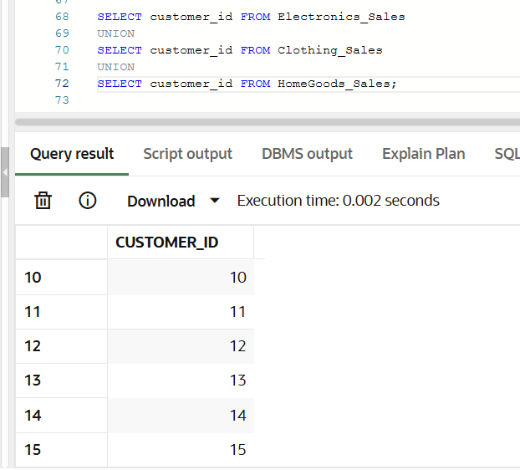

B:INTERSECT returns only the common customer IDs in all three tables.
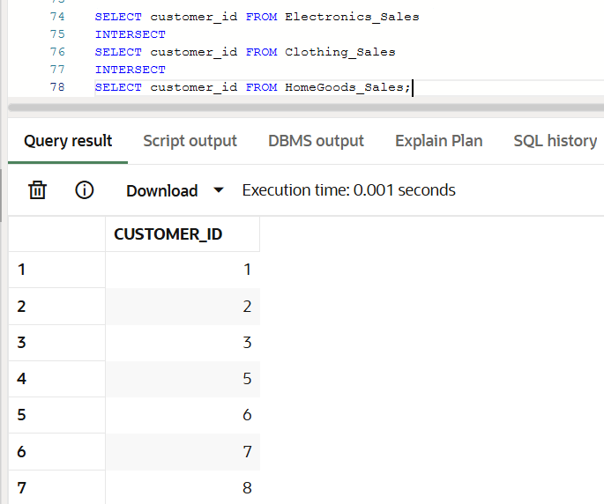

C: MINUS removes rows that appear in the second table from the first table.
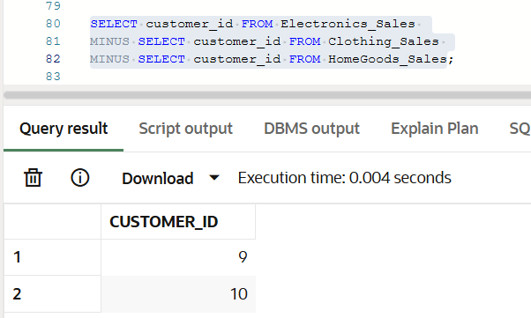

D: UNION ALL combines all customer IDs from all tables, including duplicates.
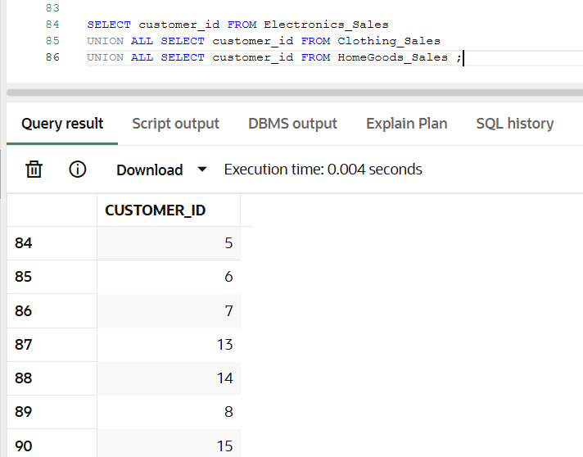

Q3.
Answer is D.

A: Incorrect. Removing duplicates adds overhead, so UNION is slower, not faster.

B: Usually true in general scenarios.However, “always” can be tricky, because in some optimized databases with small datasets, the difference may be negligible.

C: Incorrect.Duplicate removal in UNION usually requires extra work. Performance is rarely identical.

D: Correct.If there are no duplicates, the database might optimize UNION to behave like UNION ALL.If there are many duplicates, UNION has extra overhead.

Q4
Answer is B.
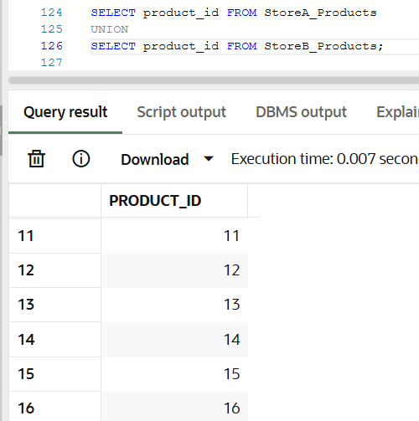

1000 (A) + 1200 (B) − 800 = 1400 unique rows.

Q5.
Answer is C.

A: Incorrect. customers that appear in both tables.
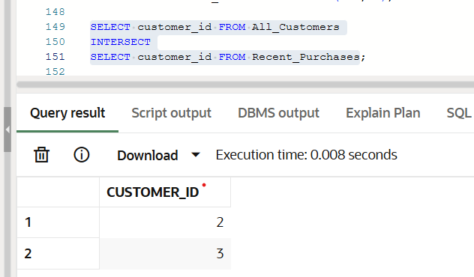

B: it returns everyone instead of filtering out purchasers; it doesn’t find “no purchases” customers.
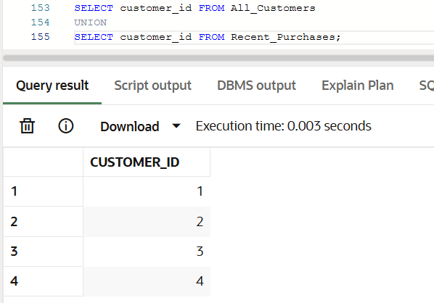

C: Correct.
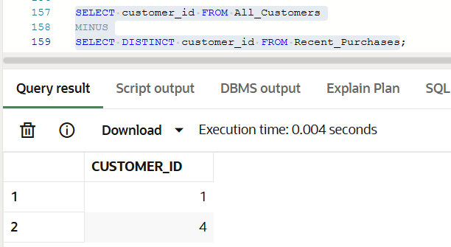

D: Wrong answer.
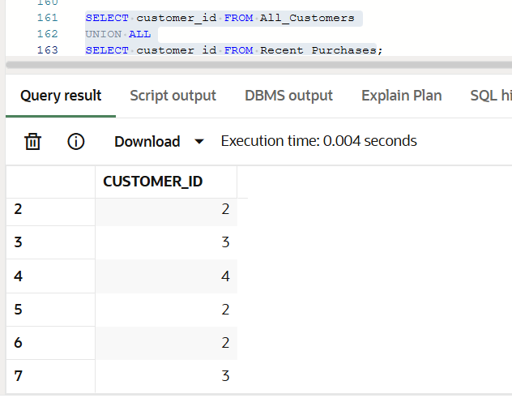

Q6.
Answer is B.

A: Returns all people, not common ones.
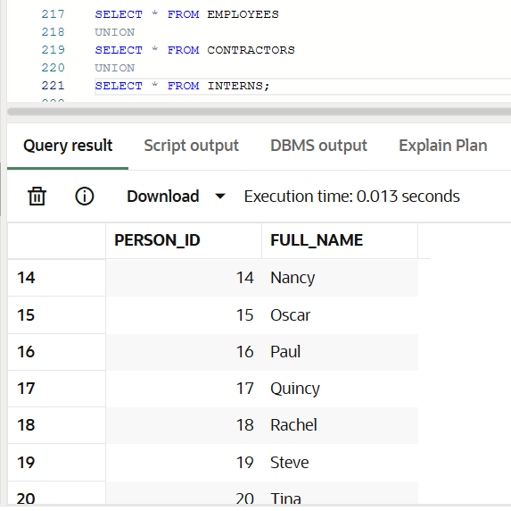

B: Returns only people in all three tables.
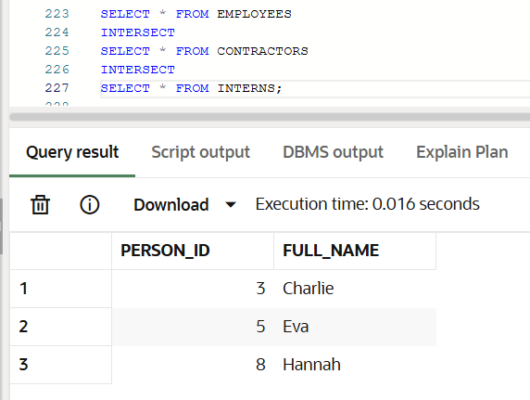
C: Returns people not in others.
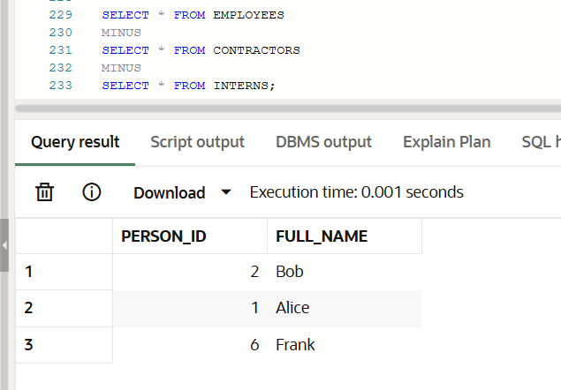

D: Always true for all employees.
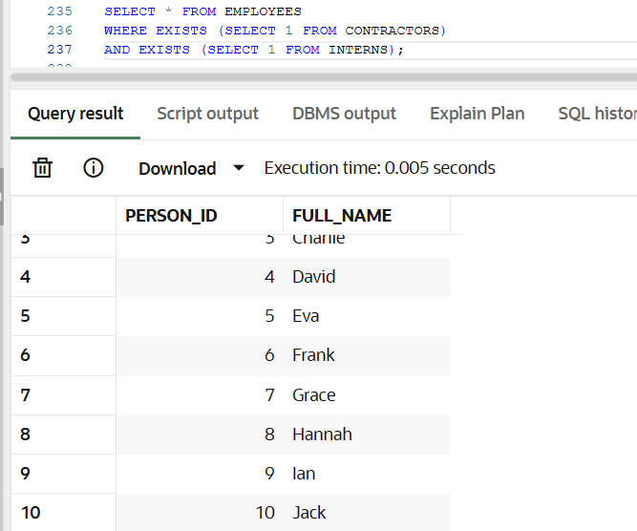

Q7.
Answer is A.

A: Selects customers who made purchases and Excludes customers who filed complaints.
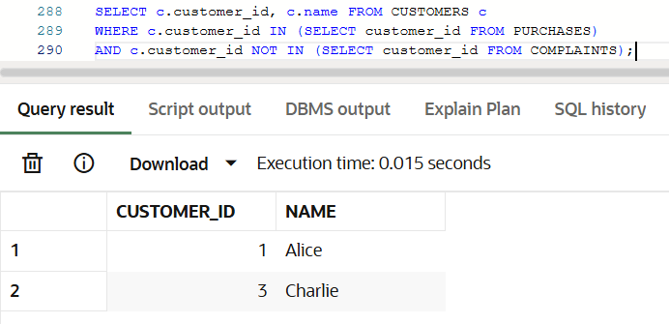

B: Correct, works in Oracle, but more complex than A.
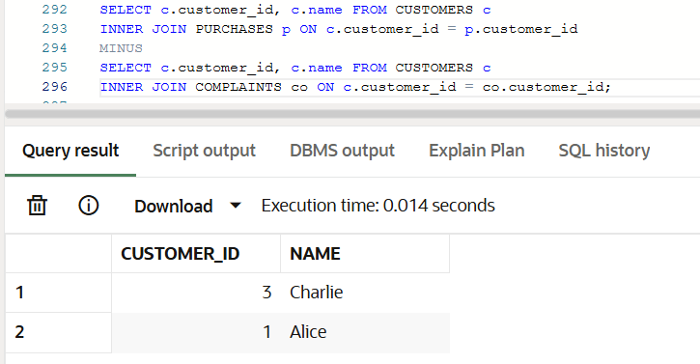

C: Works, but unnecessarily complicated.
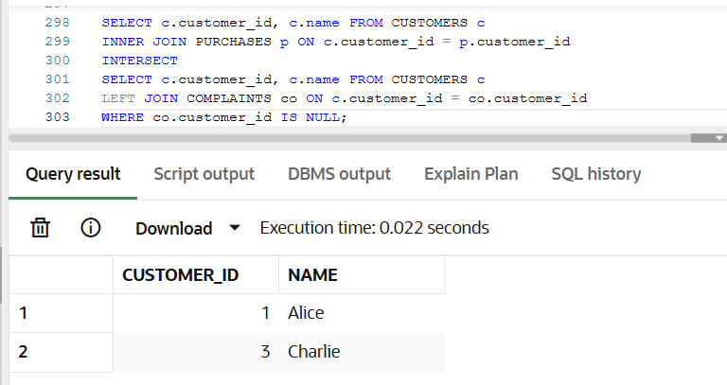

D: Incorrect.UNION ALL combines both.
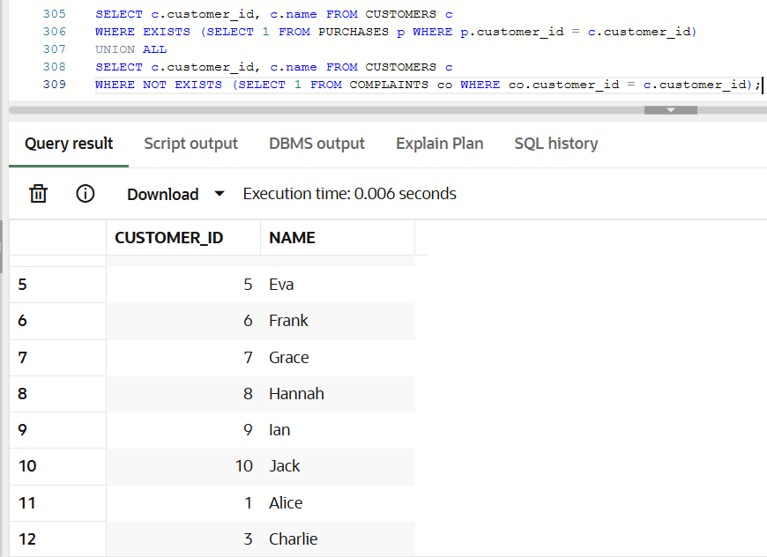

Q8.
Answer is A.

A: Combines all rows removing duplicates automatically.
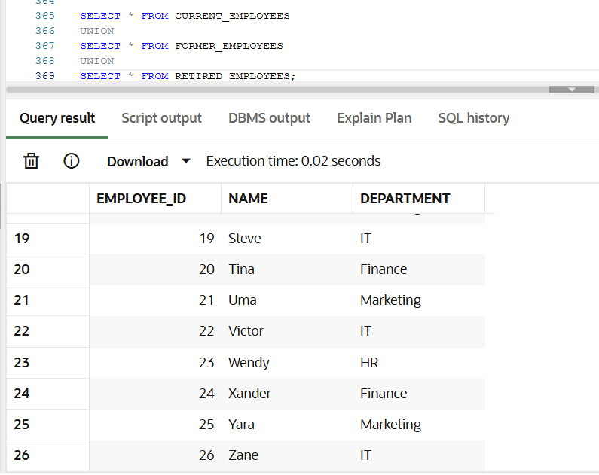

B: Incorrect. UNION ALL combines all rows including duplicates.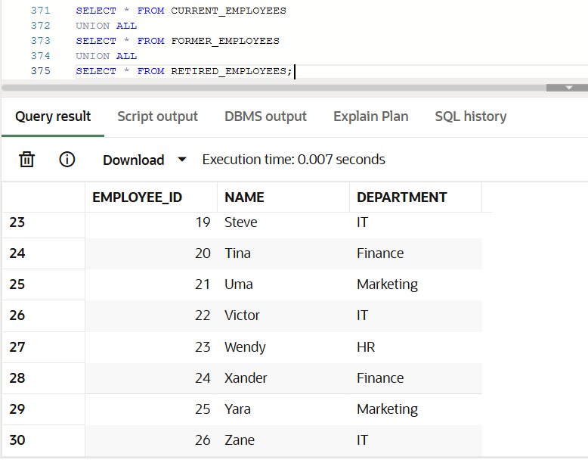
C: Incorrect. INTERSECT returns only employees present in all three tables.
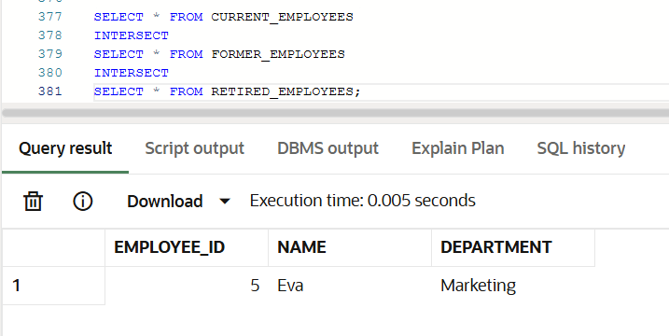

D: Incorrect. Return employees who are only in Current and not in other.
